**Impressions of Data**

**A2**

Mohit Akundi

Year 3 - B. Des[CAC]

06/10/2021

**Chosen Dataset: Formula 1**

Formula 1, known as the pinnacle of motorsports, is enjoyed by fans worldwide. It is a sport with emphasis on not only the Drivers, but also Engineering and Technology. Formula 1 teams have access to and analyse incredible amounts of data in order to judge and extract maximum performance. It is a sport where even 1/100th of a second counts.

**Possible Questions**

Being intrigued, I put down some questions I could ask with the data available. The question I decided to take forward is highlighted BLUE.

* Formula 1 cars are constantly in-development, and improve as the season progresses. Is it possible to plot the overall performance of a car race by race?
* Is it possible to draw a line of comparison between teammates driving the same car?
* Formula 1 is highly unpredictable. Sudden rain, crashes, or mistakes ruining another drivers race, as well as punctures can mask poor performance of a driver, or hide the pace of a great driver. Is it possible to plot driver performance, while reducing the impact of unpredictable circumstances?

“Is it possible to plot driver performance, while reducing the impact of unpredictable circumstances?”

This question can be answered by extracting every lap time set by a driver in-race, then finding the median of those lap times. Then repeating this for every other driver in the race. The fastest median lap time of a driver could be set to be the lowest graph, while increasing lap times draw larger bar charts

**Drawbacks:**

No analysis is bullet proof. There are circumstances where this system can be caught off-guard. While median is more bullet proof than mean, if a driver crashes out on the very first few laps, their performance will look greatly skewed (negatively).

Other factors, such as being stuck in dirty air* or DRS** trains can also negatively affect the overall pace of a driver.

**Positives:**

If a driver performs well throughout the race, but is involved in an accident, or is unfortunate with the timing of rain, one can see their performance, which race results might not show.

Often, TV coverage can focus on only so many drivers, and some excellent performances are often left out. This might help them get the recognition the coverage might have missed.

Often, media complains about certain drivers’ performance being poor, while in reality, they are simply unlucky with other factors, such as pit stops and strategy, not their speed.

*************************************************************************

*Dirty air, is when a driver is stuck behind another car but unable to overtake. The “dirty air”, or wind vortices from the car ahead, leads to loss of downforce, and drop in grip levels of the car, making it difficult to drive.*

*DRS is a system, designed to help cars directly behind another to follow, by allowing a rear wing flap to open, increasing top speed. So while Dirty Air slows them in the corners, DRS allows the car behind to “catch up” on a straight.*

*However, if multiple cars are following closely one behind another, all of them have DRS enabled, which leads to everyone behind the lead car getting stuck behind.*

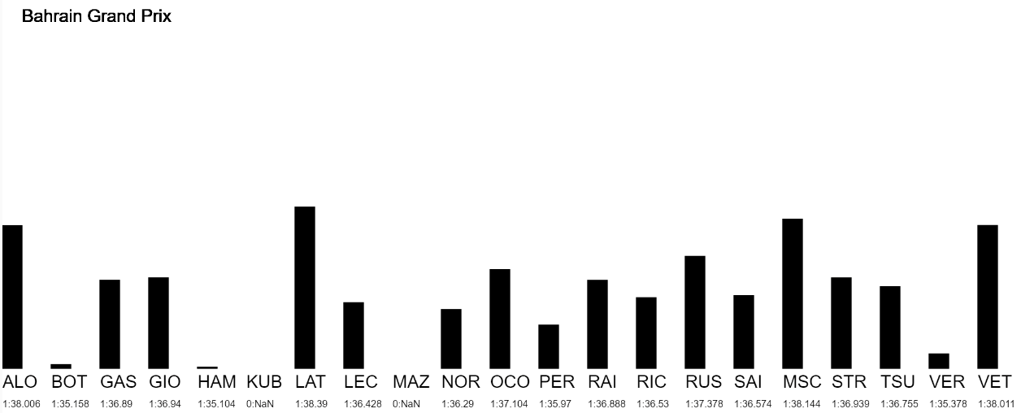**Ideations:**

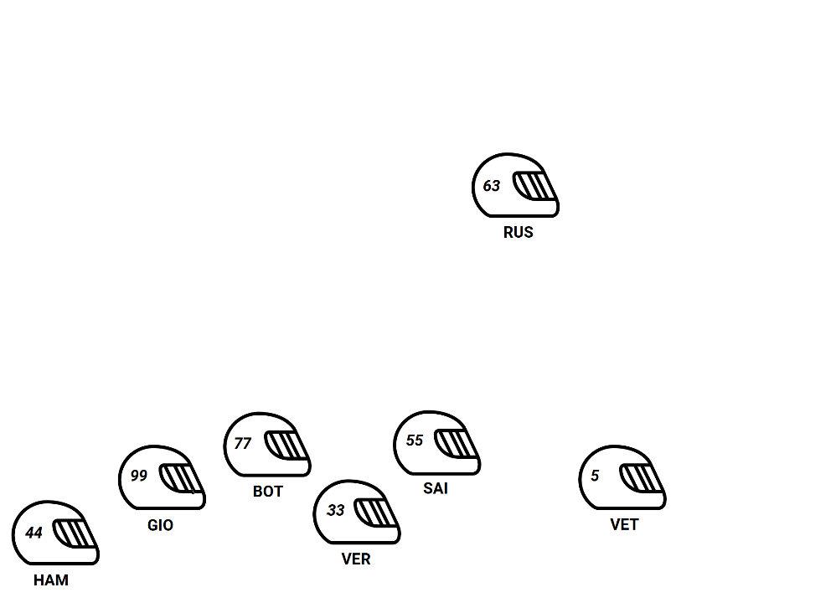

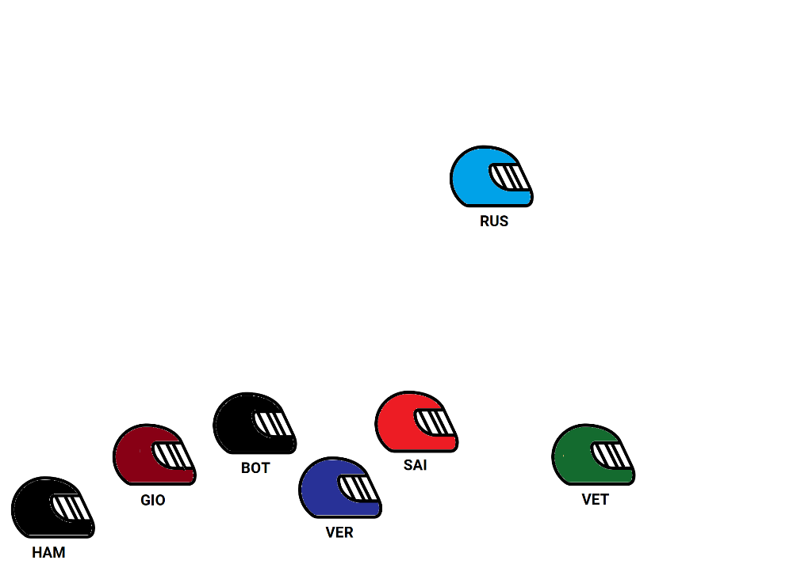

**Feedback:**

During the Feedback sessions, my ideas were still not finalised.

The Primary Feedback received, was to *“make the representation livelier” and “allow the user to choose which data they wish to see”.*

**Explorations and Current Progress:**

[p5.js Web Editor | Formula 1 Russian GP 2021 (p5js.org)](https://editor.p5js.org/Mohit.A/sketches/tcRWta5S8)

[p5.js Web Editor | F1 Car Performance Year By Year (p5js.org)](https://editor.p5js.org/Mohit.A/sketches/4ZEwV3FzV)

[p5.js Web Editor | F1 Car Performance Year By Year X2 (p5js.org)](https://editor.p5js.org/Mohit.A/sketches/R0oTTDJMH)

[p5.js Web Editor | F1 Car Performance Year By Year X3 (p5js.org)](https://editor.p5js.org/Mohit.A/sketches/CJoG8TNJz)

[p5.js Web Editor | F1 Car Performance Year By Year X4 (p5js.org)](https://editor.p5js.org/Mohit.A/sketches/x2LrTP6Z1)

[p5.js Web Editor | F1 Car Performance Year By Year X5 (p5js.org)](https://editor.p5js.org/Mohit.A/sketches/ooSrbhf0c)

**Source of Data:** [**Ergast Developer API**](http://ergast.com/mrd/)

**Why Ergast ?**

Ergast is a free, experimental API, providing historical Formula 1 data since its beginning, 1950.

It is completely free, for non-commercial purposes.

Since the Data for this project is coming from an always updating site, along with being fetched using an API, I can keep generating the median-lap times for years to come with no need of manually downloading any files.

Being dedicated solely for Formula 1 data, any updates and new features added to it, might indirectly benefit the project.

Benefits from extremely easy formatting.

EG: https://ergast.com/api/f1/2008/15/drivers/hamilton/laps